Purpose
To establish a standard procedure for grossing of benign and malignant neoplastic lung specimens.

Background
Examples of primary neoplastic lung tumors include carcinomas (i.e., squamous cell carcinoma, adenocarcinoma, small cell carcinoma, and large cell carcinoma)—which account for greater than 90% of cases—bronchial carcinoids, and other, rarer, miscellaneous tumors, such as those of mesenchymal origin. The pleura is also a site of primary neoplastic tumors (i.e., solitary fibrous tumors and malignant mesothelioma). Due to its vast network of blood vessels and lymphatics, the lungs are the most common site of metastasis for cancers from other areas of the body.
Wedge resections (Figure 1) are performed to sample smaller superficial neoplasms or neoplasms occurring in high-risk patients unable to endure more extensive procedures.
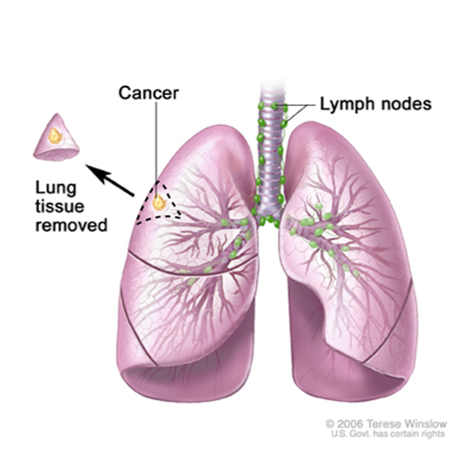
Figure 1

Lobectomies (Figure 2) or pneumonectomies (Figure 3) are performed for larger and deeper tumors. Pneumonectomies may also include adherent parietal pleura, portions of chest wall, diaphragm, and pericardium in cases of advanced tumors or malignant mesotheliomas, and are known as extrapleural pneumonectomies.
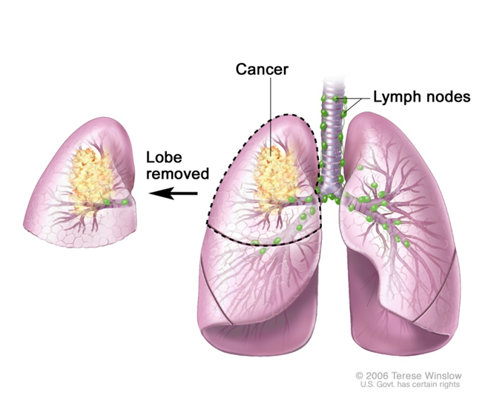
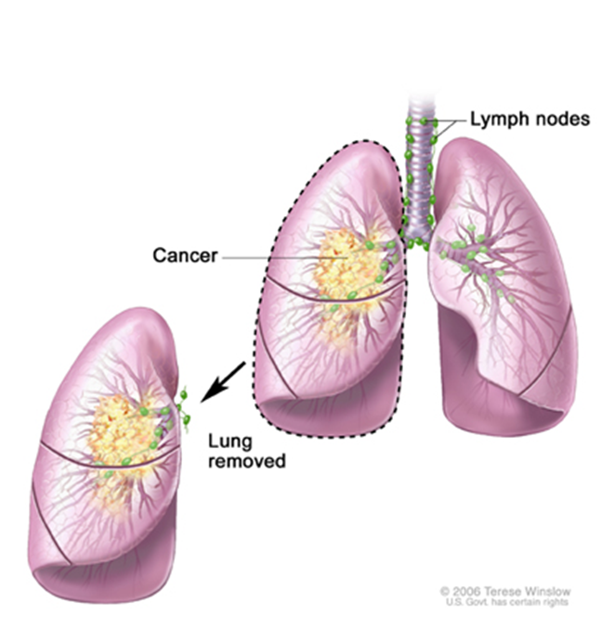
Figure 3
Figure 2
Pleurectomies (Figure 4) are performed in cases of mesothelioma deemed unresectable for purposes of debulking.
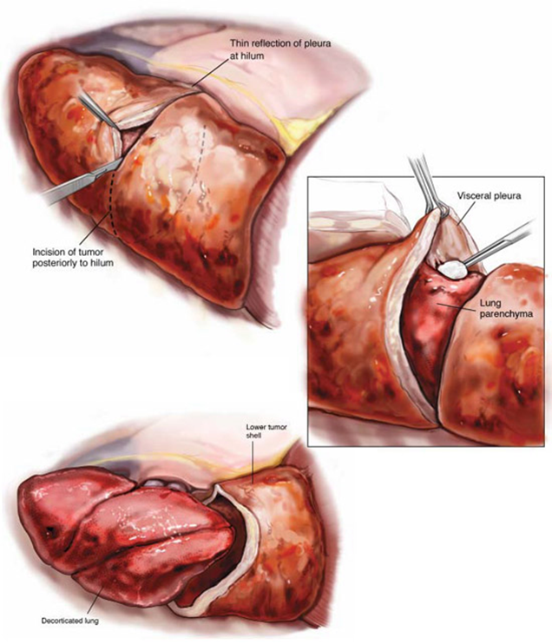
Figure 4

Procedure
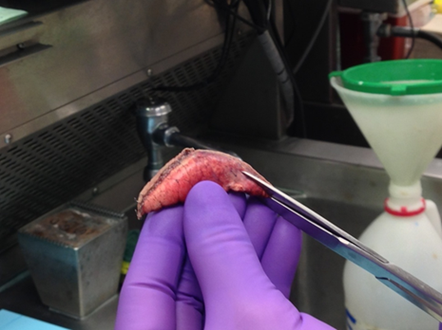
Neoplastic Lung Wedges

- Measure the specimen in 3-dimensions.
- Document the number and length of the staple lines.
- Examine and describe the pleural surface. Is there retraction of the pleura, or does it move freely over the tumor? Ink any adherent tissue (e.g., fat, muscle).
- With a sharp pair of scissors, shave off the staple line(s), being sure to stay as close as possible to the staples (Figure 5). Blot dry and apply ink to the newly-exposed parenchyma; this represents the parenchymal resection margin.
Figure 5
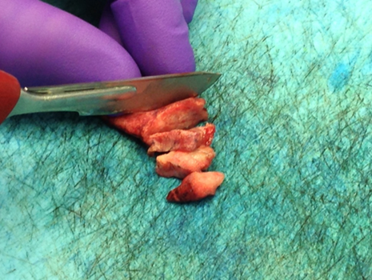
- Bread loaf the specimen (Figure 6) and describe all tumors present—specifically their size, cut surfaces, involvement of pleura, and distance from the resection margin.
- Describe the uninvolved lung parenchyma.
- Submit the entire tumor, including sections demonstrating its relationship to margin, pleura, and adjacent “normal” parenchyma. If tumor is over 3 cm, submit 1 section per cm of tumor.

Figure 6

Example dictation:

Received in formalin, labeled “LUL wedge”, is a 4.8 x 3.6 x 2.5-cm lung wedge with a single 5.2-cm staple line.

The specimen is remarkable for a 2.0 x 1.7 x 1.5-cm, tan, solid and well-circumscribed parenchymal mass. The mass abuts—but does not appear to involve—the pleura and is within 0.5 cm of the parenchymal resection margin (inked blue).

The pleura is firm and slightly retracted overlying the tumor, however, is otherwise unremarkable. The uninvolved pulmonary parenchyma is bright red and consolidated. No other discrete lesions are appreciated.

Cassette summary:
A-1 thru A-3. Mass, including margin, pleura, and adjacent uninvolved parenchyma. (1ss ea.)

Neoplastic Lobectomies

- Weigh the specimen.
- Remove the staple lines from the hilar structures, being sure to stay as close as possible to the staples (Figure 7).
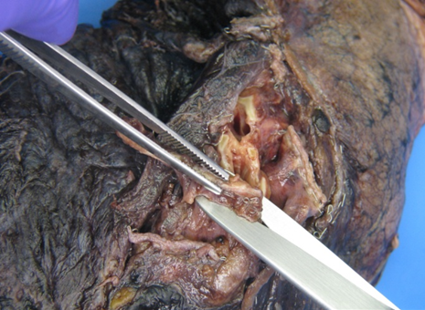
- Shave and submit the bronchial and vascular resection margins en face in your first cassette. You can use red ink to highlight the true margin for the embedding histotech or place the true margin face down in the cassette between two sponges.
- Optional: Using a syringe, insufflate the lobe with formalin through the bronchus (Figure 8). After the lobe is sufficiently insufflated, clamp the bronchus with hemostats to prevent backflow of formalin. Immerse lobe in formalin for 4-6 hours.
Figure 7
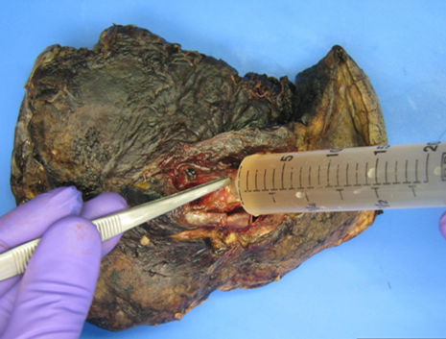
- Measure the overall specimen and bronchial remnant.
- Search for and submit all hilar and peribronchial lymph nodes. The nodes will be black from anthracosis. Don’t worry if you can’t remove them intact; N staging for lung cancer is based on location of involved nodes and not number.
- Describe the pleural surface (e.g., smooth and glistening, dull with adhesions, retracted and immobile, tumor implants, etc.). Ink any adherent tissue (e.g., fat, muscle).
- With a sharp pair of scissors, remove the parenchymal staple lines, being sure to stay as close as possible to the staples. Blot dry and apply ink to the newly-exposed parenchyma; this represents the parenchymal resection margin.
Figure 8
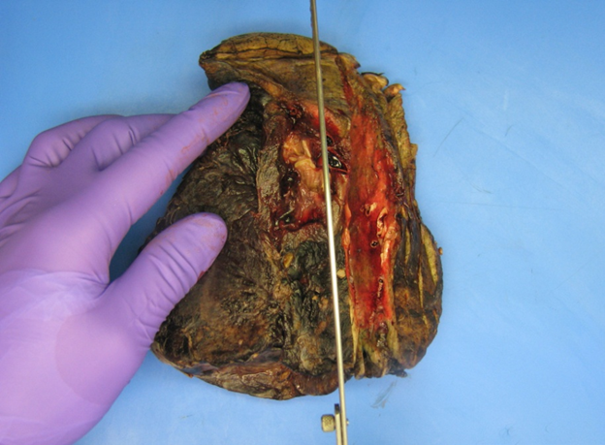
- Serially section the lobe in the plane that best reveals the tumor and its relationship to adjacent structures; for proximal lesions, coronal sections best demonstrate this relationship (Figure 9).
- Describe all lesions present, specifically their size, cut surfaces (e.g., color and consistency), borders (e.g., well-circumscribed, poorly-circumscribed, stellate), distance to resection margins, and involvement of bronchi or vessels.
- Describe the uninvolved lung parenchyma and any abnormalities of the bronchi (i.e., bronchiectasis, mucus plugging).
Figure 9
- Obtain representative sections of tumor(s) (at least 1 section per cm of tumor), showing its relationship to bronchi, vessels, and adjacent uninvolved parenchyma.

Example dictation:

Received in formalin, labeled “left lower lobe”, is a 142-g, 11.5 x 8.7 x 3.5-cm left lower lobe of lung with attached bronchial remnant (0.8 cm L x 1.1 cm dia).

The specimen is remarkable for a 3.8 x 3.2 x 3.0-cm mass that has solid, tan-white, friable and focally hemorrhagic cut surfaces with poorly-circumscribed, infiltrative borders. The mass is ≥1.5 cm from the hilar resection margins, however, abuts and likely involves the overlying pleura, which is tan-white and puckered. The parenchymal resection margin is widely free of the tumor.

The uninvolved pleura is red-brown, smooth and glistening. The uninvolved pulmonary parenchyma is bright red and consolidated. No additional discrete lesions are appreciated.

Cassette summary:
A-1. Bronchial margin, shaved and submitted en face. (1ns)
A-2. Vascular margins, shaved and submitted en face. (4ns)
A-3 & A-4. Hilar and peribronchial lymph nodes (6 ns)
A-5 thru A-9. Representative sections of mass, with abutted pleura in A-5 thru A-7 and adjacent uninvolved parenchyma in A-8 & A-9. (1ss ea.)
A-10. Representative section of uninvolved parenchyma. (1ss)

Neoplastic Pneumonectomies

- Weigh the specimen.
- Remove the staple lines from the hilar structures, being sure to stay as close as possible to the staples.
- Shave and submit the bronchial and vascular resection margins en face in your first cassette. You can use red ink to highlight the true margin for the embedding histotech or place the true margin face down in the cassette between two sponges.
- Optional: Using a syringe, insufflate the lung with formalin through the bronchus. After the lung is sufficiently insufflated, clamp the bronchus with hemostats to prevent backflow of formalin. Immerse lung in formalin overnight.
- Measure the overall specimen and bronchial remnant.
- Search for and submit all hilar and peribronchial lymph nodes. The nodes will be black from anthracosis. Don’t worry if you can’t remove them intact; N staging for lung cancer is based on location of involved nodes and not number.
- Describe the pleural surface (e.g., smooth and glistening, dull with adhesions, retracted and immobile, tumor implants, etc.). Ink any adherent tissue (e.g., fat, muscle).
- Serially section the lobe in the plane that best reveals the tumor and its relationship to adjacent structures; for proximal lesions, coronal sections best demonstrate this relationship.
- Describe all lesions present, specifically their location (lobe), size, cut surfaces (e.g., color and consistency), borders (e.g., well-circumscribed, poorly-circumscribed, stellate), distance to resection margins, and involvement of bronchi, vessels and/or other lobes.
- Describe the uninvolved lung parenchyma and any abnormalities of the bronchi (i.e., bronchiectasis, mucus plugging).
- Obtain representative sections of tumor(s) (at least 1 section per cm of tumor), showing its relationship to bronchi, vessels, other lobes, and adjacent uninvolved parenchyma.
Example dictation:

Received in formalin, labeled “left lung”, is a 284-g, 20.3 x 15.5 x 3.8-cm left lung with attached bronchial remnant (1.0 cm L x 1.2 cm dia).

The specimen is remarkable for a firm mass (5.5 x 3.2 x 3.2 cm) in the inferior-most portion of the upper lobe, which ulcerates through the pleura to involve the superior-most portion of the lower lobe. The mass has solid, tan-white, friable and focally hemorrhagic cut surfaces with poorly-circumscribed, infiltrative borders. The mass comes to within 1.5 cm of the hilar margins and abuts—but does not appear to invade—an adjacent blood vessel.

The uninvolved pleura is red-tan, smooth and glistening with few scattered fibrous adhesions. The uninvolved parenchyma is tan and spongy to bright red and consolidated. Multiple possible hilar and peribronchial lymph nodes are identified (0.2 – 0.8 cm). No other discrete lesions or abnormalities are appreciated.

Cassette summary:

A-1. Bronchial margin, en face. (1ns)
A-2. Vascular margins, en face. (4ns)
A-3. Hilar and peribronchial lymph nodes. (5ns)
A-4 thru -7. Mass to adjacent uninvolved parenchyma, including abutted vessel in A7. (1ss ea.)
A-8 and -9. Mass invading through pleura into the lower lobe. (1ss ea.)
A-10. Left lower lobe. (1ss)

Pleurectomies

- Measure the overall specimen and any adherent soft tissue (e.g., fat, muscle).
- Describe the pleura/tumor. Does the tumor invade into any adherent soft tissue?
- Submit representative sections of tumor (at least 1 per centimeter) and include any attached soft tissue.

Example dictation:

Received in formalin, labeled “pleura and left lower lobe”, is a 15.0 x 12.2 x 4.5-cm pleurectomy specimen with an adherent portion of skeletal muscle (4.5 x 3.6 x 1.2 cm).

The pleura is diffusely thickened (0.3-0.5 cm) and indurated with solid, white-tan, focally hemorrhagic cut surfaces (grossly consistent with mesothelioma). The tumor invades 0.4 cm into the adherent portion of skeletal muscle and is 0.8 cm from the resection margin (inked blue).

Cassette summary:
A-1 thru A-3. Skeletal muscle invaded by pleural tumor to include closest resection margin. (1ss ea.)
A-4 thru A-8. Pleural tumor. (3ss ea.)

References
- Kumar V, Abbas AK, Fausto N, Robbins SL, Cotran RS. Robbins and Cotran Pathologic Basis of Disease. 7th ed. Philadelphia, PA: Elsevier Saunders; 2005.
- Lester SC. Manual of Surgical Pathology. 3rd ed. Philadelphia, PA: Mosby/Elsevier; 2010.
- PDQ Cancer Information Summaries [Internet]. Bethesda (MD): National Cancer Institute (US); 2002-. [Figure, Wedge resection of the lung...] Available from: https://www.ncbi.nlm.nih.gov/books/NBK65951/figure/CDR0000322895__2/
- PDQ Adult Treatment Editorial Board. Non-Small Cell Lung Cancer Treatment (PDQ®): Patient Version. 2020 May 20. In: PDQ Cancer Information Summaries [Internet]. Bethesda (MD): National Cancer Institute (US); 2002-. [Figure, Lobectomy. A lobe of the lung is removed.] Available from: https://www.ncbi.nlm.nih.gov/books/NBK65917/figure/CDR0000062956__298/
- PDQ Cancer Information Summaries [Internet]. Bethesda (MD): National Cancer Institute (US); 2002-. [Figure, Pneumonectomy. The whole lung is removed.] Available from: https://www.ncbi.nlm.nih.gov/books/NBK65951/figure/CDR0000046224__2/
- Goodman MD. Regional Therapeutics for Advanced Malignancies. 1/e. New Delhi: Jaypee Brothers Medical Publishers; 2012.

